**Data and Visualization basics:**

Data : Structured and unstructured

Quantitative and Categorial (nominal and ordinal – in order)

Quantitative (numeric) - Continuous (weights) and Discrete (whole number like number of students)

**TITLE**

# LECTURE TITLE

**Types of Data**

1. Structured data is organized, follows a clear format, and is easy to work with. (Ex: Table data, JSON, XML)
2. **Unstructured data** lacks a specific structure, is more diverse in content, and requires specialized tools and techniques for analysis. (Ex: Audio, Video, Free Form Text)
3. **Categorical data** represents categories, labels, or distinct groups. It is used to classify and categorize

items or observations based on certain characteristics or attributes.

1. **Numeric data** consists of numerical values that represent measurable quantities or continuous variables.

**TITLE**

**LECTURE TITLE**

# Types of Data

1. **Nominal data** consists of categories or labels with no inherent order or ranking.
2. **Ordinal data**, unlike nominal data, has a specific order or ranking among categories.
3. **Continuous data** encompasses an infinite range of precise values, often with decimals.
4. **Discrete data**, on the other hand, comprises distinct, countable numerical values.

**TITLE**

**LECTURE TITLE**

# Pie and Bar Chart

1. Use a **bar chart** when you have benchmark values to compare with.
2. Use a Horizontal bar chart when **category labels** are long.
3. Use a Horizontal bar chart instead of a pie chart when the number of categories is **more than 5.**
4. Use a vertical bar chart for **time series data.**
5. Consider a **Clustered Column** chart for comparing multiple data series within distinct categories.

**TITLE**

**LECTURE**

# Histogram and Line Chart TITLE

1. Histograms are primarily used to show the **frequency distribution** of a continuous or discrete dataset.
2. In a histogram, all bins are of **equal size.**
3. A line chart is useful in presenting the **trend or change** in data over a period.
4. A stacked column chart used to represent and compare multiple categories in a single bar, while also displaying the overall total.

**TITLE**

**LECTURE**

# Scatter and Bubble Plot TITLE

1. **A scatter plot** is a graph that uses a grid to present data values, typically involving two variables within a dataset.
2. Scatter plots help to visualize the **relationship between two variables.**
3. **A Bubble chart** is a variation of a Scatter Plot that allows you to represent a third variable through the size of the bubbles.
4. Scatter plots and Bubble Charts help to detect **outliers,** visualize the **relationship** between two variables, and also Identify **trends.**

**TITLE**

**LECTURE**

# Univariate vs Bivariate vs Multivariate analysis TITLE

1. **Univariate analysis =** Analysis of a **single** variable
2. **Bivariate analysis =** Analysis of **two** variables
3. **Multivariate analysis =** Analysis of > **two** variables

**Numpy**

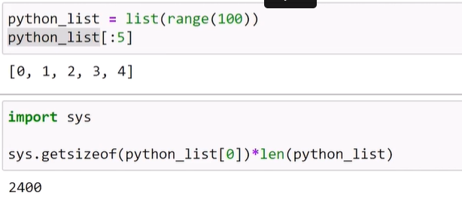

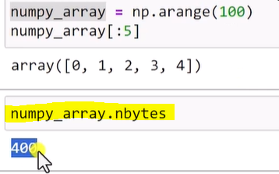

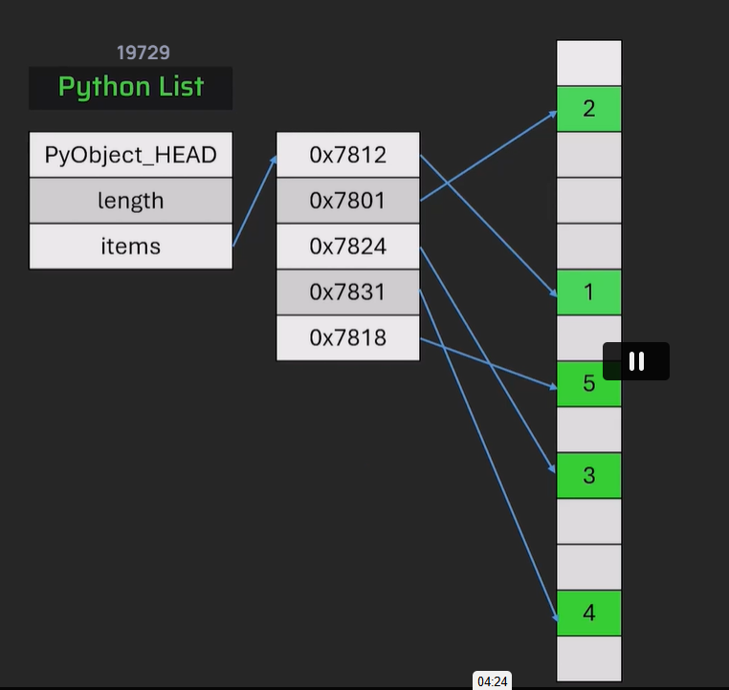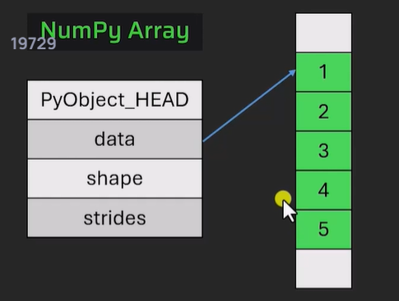

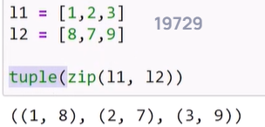

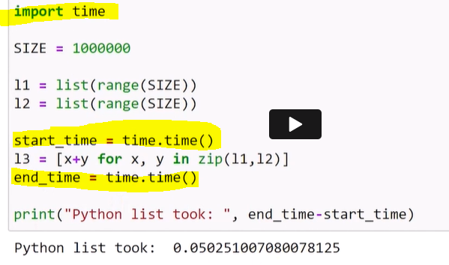

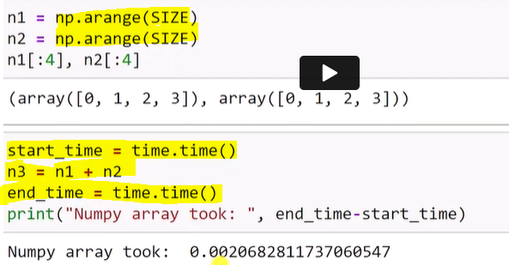

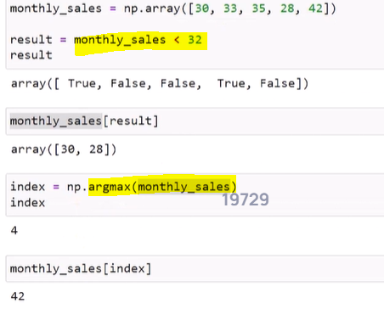

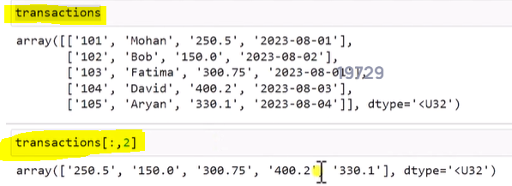

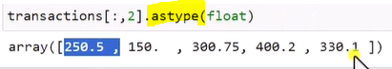

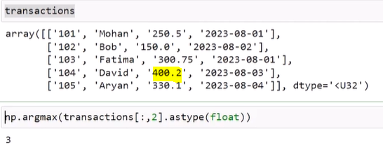

**Prints second row based on transaction id value**

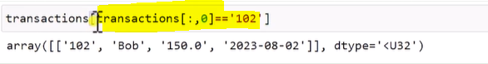

import numpy as np

a = np.array([[1,2],[4,5]])

a.ndim

a.shape

a.size

a.dtype

a.itemsize – bytes information

a1 = np.ones((3,4))

a2= np.arange(10)

a.flatten()

a.reshape(3,2) - data count should be compatible

a.sum(axis=0) -> vertical addition or column addition

a.sum(axis=1) = > horizontal or row addition

for row in a

print(row) - prints each row

import numpy as np

n1 = np.array([1,"hi"])

print(n1.dtype) -> U21

------------

import numpy as np

n1 = np.array([1,2], dtype=np.float64)

print(n1.dtype) –> float64

----------------

import numpy as np

b = np.array([1,2,4,5])

np.sum(b)

np.sqrt(b)

np.sort(b)

np.std(b)





import numpy as np

a = np.array([[1,2],[4,5]])

b = np.array([[1,2],[4,5]])

#print(a[:,1:2]) # all rows and second colum (3 is not inclusive)

c = a+b

print(a)

print(b)

d = np.hstack((a,b))

print(d)

e = np.vstack((a,b))

print(e)

-----------------------

import numpy as np

a = np.array([[1,"A"],[2,"B"]])

b = np.array([[3,"C"],[4,"D"]])

#print(a[:,1:2]) # all rows and second colum (3 is not inclusive)

print(b)

d = np.hstack((a,b))

#print(d)

e = np.vstack((a,b))

#print(e)

f = np.hsplit(a,[1])

print(f)

g = np.split(b,[1])

print(g)



**5.1 Pandas introduction and installation**

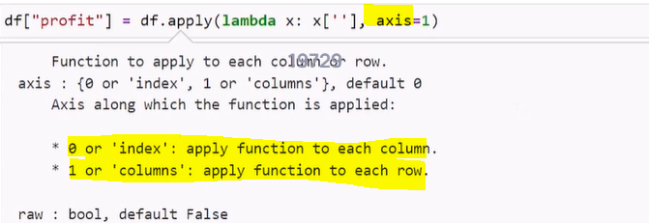

**Adding profit column**

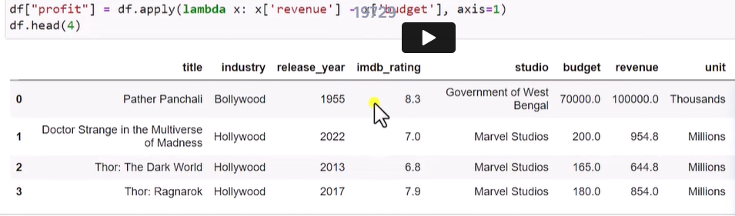

import pandas as pd

df = pd.read_csv('data.csv')

print(df.head())

print(df.head(5))

print(df.sample(5))

print(df.shape)

print(df.columns)

print(df.<column>.unique())

print(df{“<column>”].unique())

print(df["Duration"]) - column display

print(df.Duration) - column display – this is Series type

print(df.Duration.min())

print(df.Duration.max())

print(df.Duration.mean())

df1= df[df.Duration>100] - takes all record with this condition

import pandas as pd

df = pd.read_csv('data.csv')

#print(df.Pulse)

#print(df.columns)

print(df.head(5))

print(df.Duration.min())

print(df.Duration.max())

print(df.Duration.value_counts()) - show count of each unique value

import pandas as pd

df = pd.read_csv('data.csv')

print(df[['Duration', 'Calories']])

import pandas as pd

df = pd.read_csv('data.csv')

print(df[(df.Duration>=60)& (df.Duration <100)])

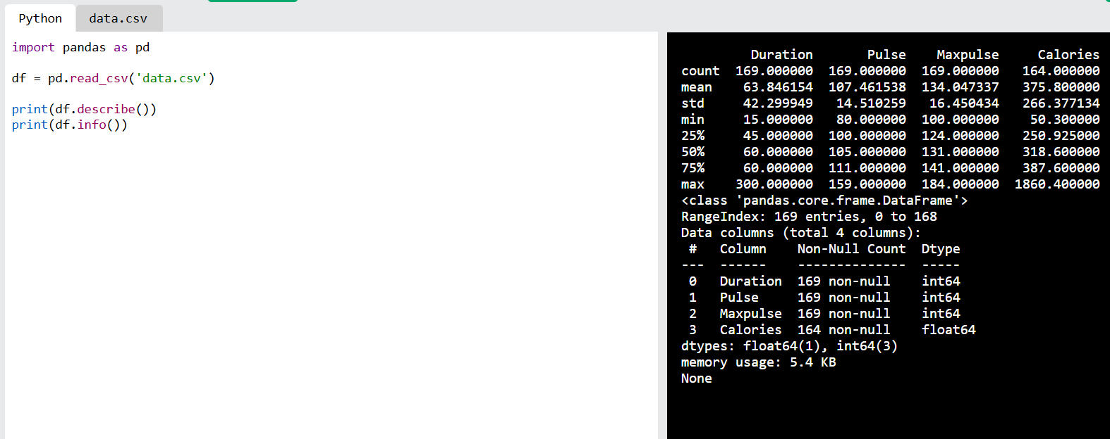

import pandas as pd

df = pd.read_csv('data.csv')

print(df[df.Duration>=df.Duration.max()])

print(df.Duration.value_counts())

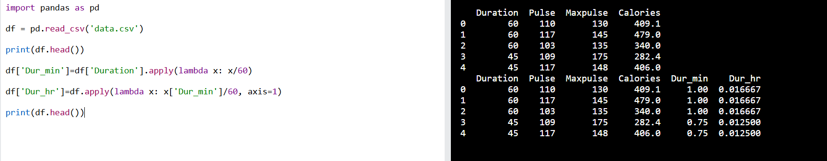

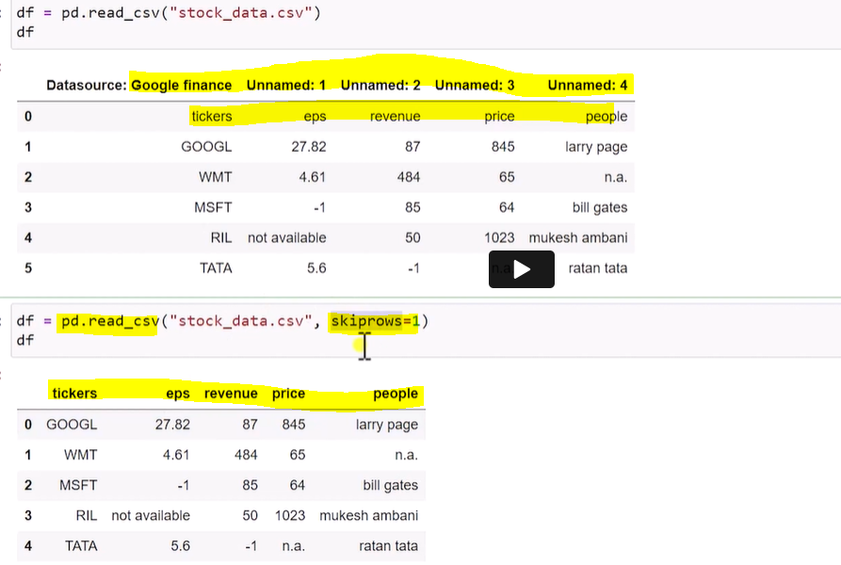

**Adding own column names**

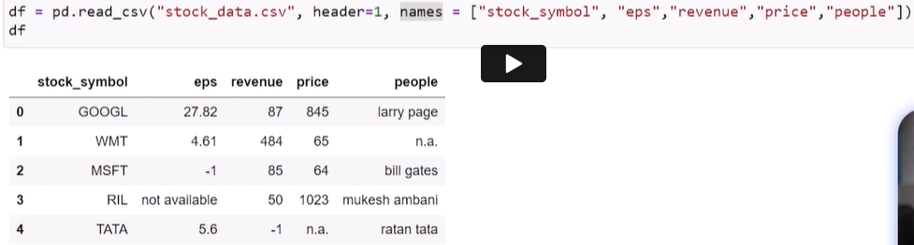

**Read only certain rows**

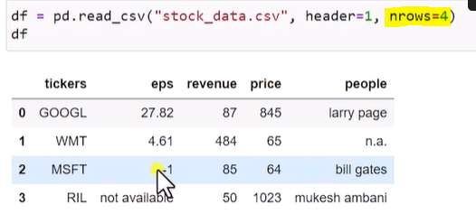

import pandas as pd

df = pd.read_csv('data.csv')

print(df.index)

print(df.loc[1])

print(df[0:2])

import pandas as pd

df = pd.read_csv('data.csv', header=1, nrows=10, names = ["D", "P","M", "C"])

print(df) -  **header from the data in 1st index**

df = pd.read_csv('data.csv', na_values=[“-1”, ‘Not available’]) - **adds Nan inplace of these values for all columns**

df = pd.read_csv('data.csv', na_values={‘price’:[“-1”], ‘Rate’: [‘Not available’]} ) - **adds Nan inplace of these values for the mentioned columns**

df.to_csv(“name.csv”, index=False, header=False)

**pip install openpyxl**



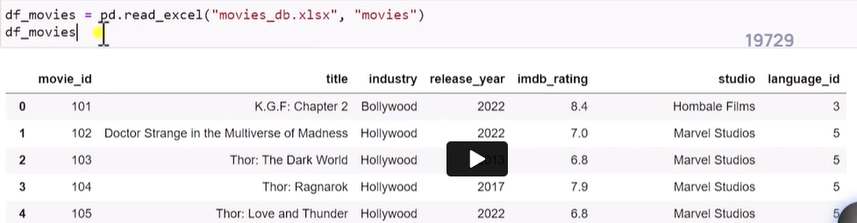



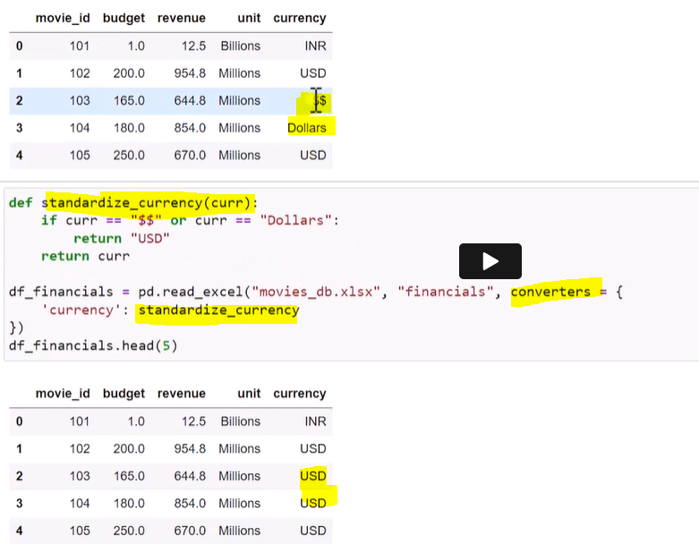





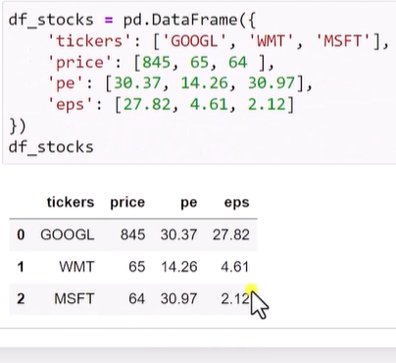



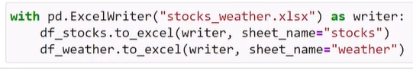

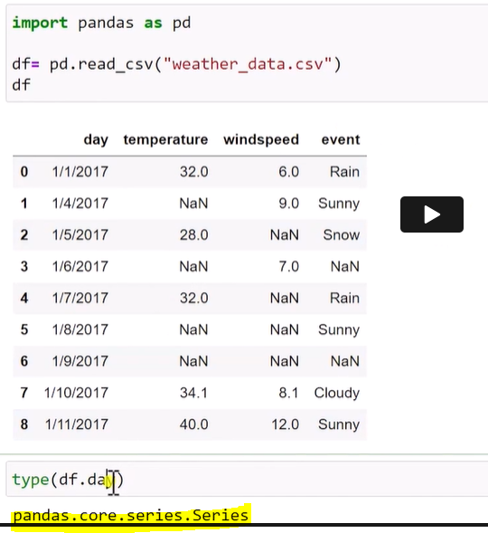

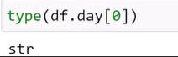

df = pd.read_csv(“weather_data.csv”, parse_dates=[“day”]) - **changing to date format for day column**

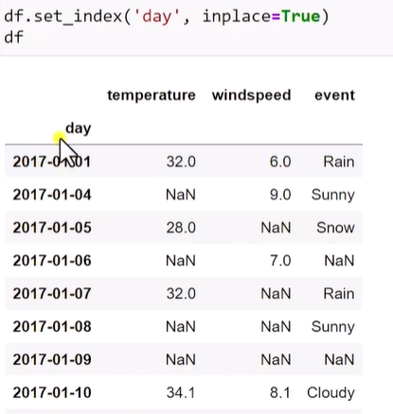

df.fillna(0, inplace=True)

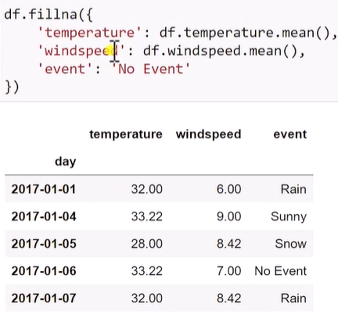

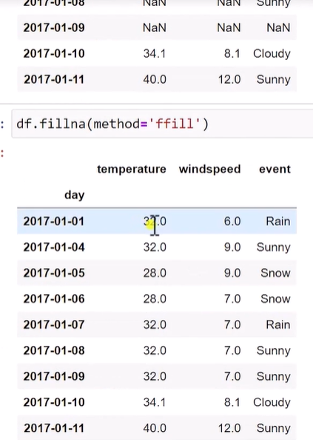

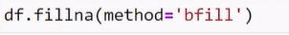

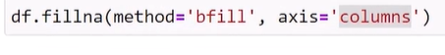

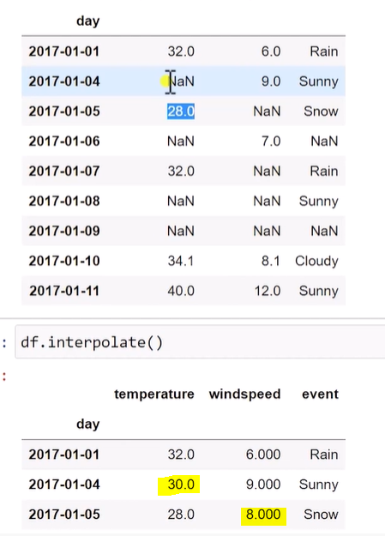

Df.dropna(how=’all’) – drops records if it has na value in all columns

Df.dropna(how=’any’) - drops record if any one column has is na value

Df.dropna(threshold=1) = keep record if any record has one valid column value

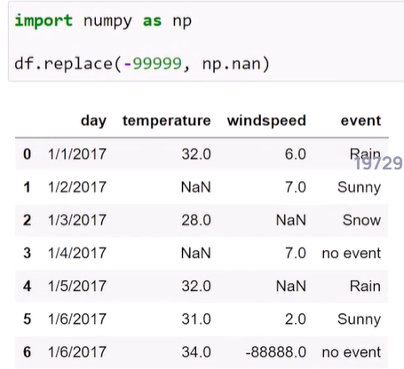

**Replacing values if present anywhere**

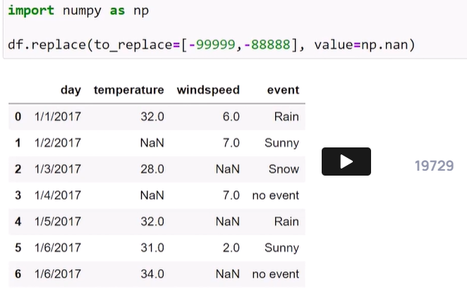

**Replacing column wise values**

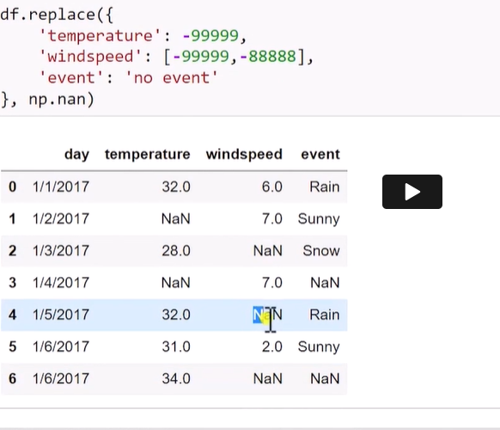

Replace anywhere for these values individually

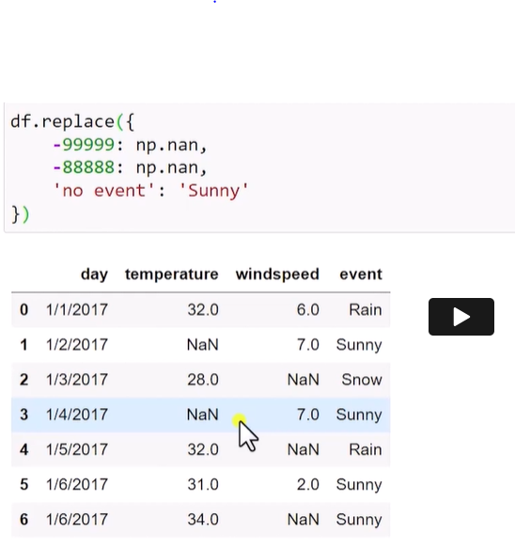

**Creating DataFrame**

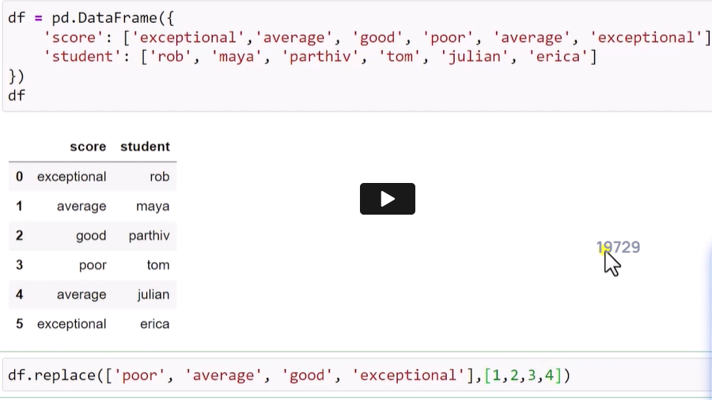

Filtering column and taking max value

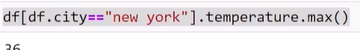

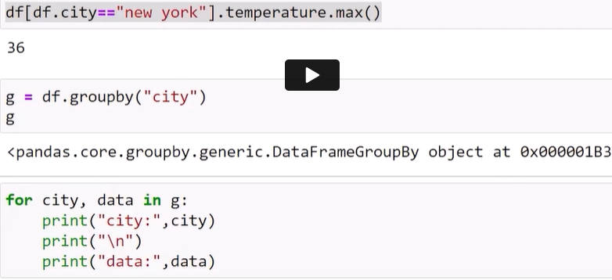

**Group by creating different df for each value. Each data frame can be accessed individually using for loop**

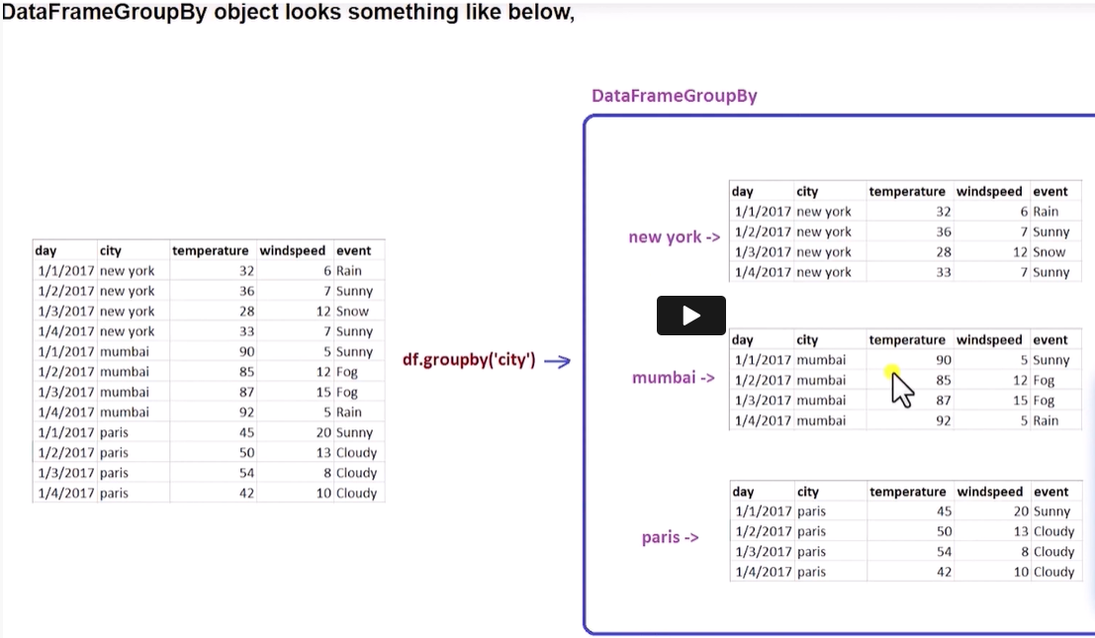

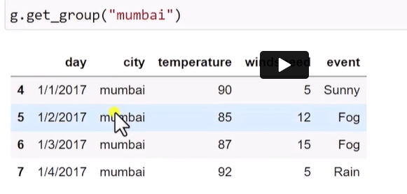

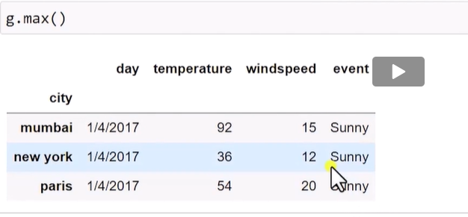

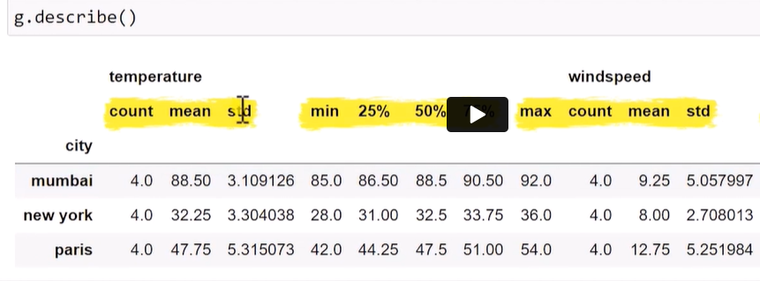

g.size()

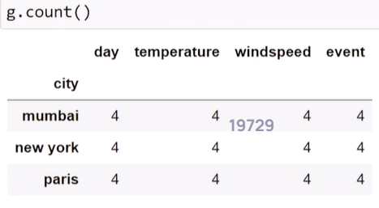

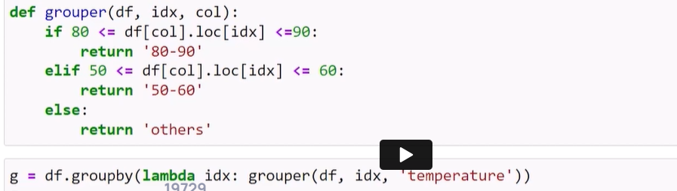

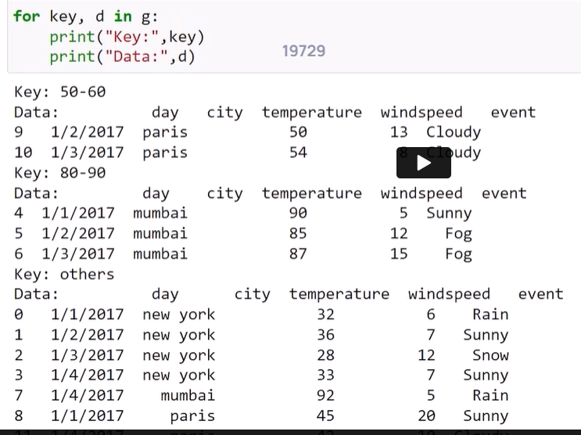

**Concatenation**

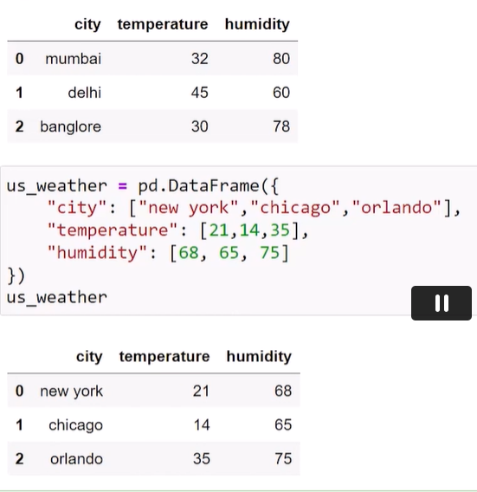

**Takes index from two dataframes**

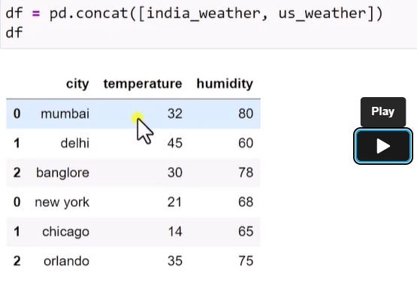

**Source index is ignored**

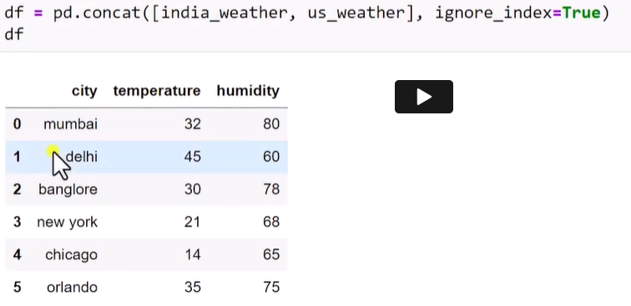

**Create new index for each dataframe**

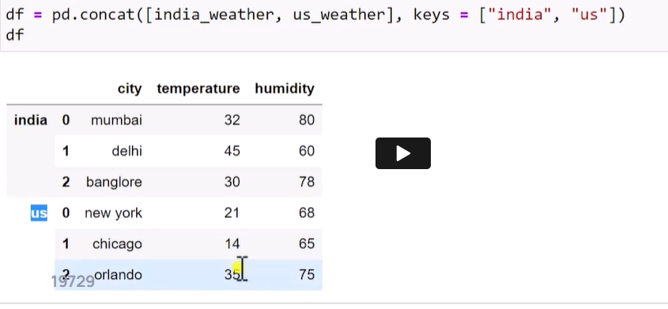

**Concatenate both df**

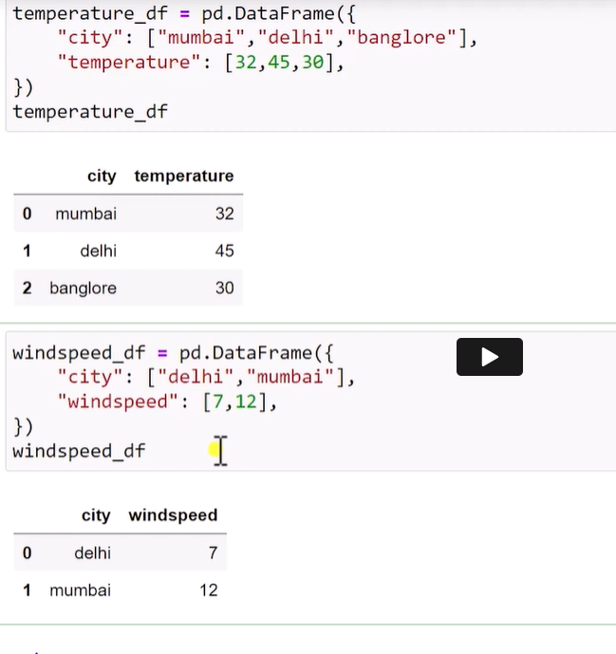

**Changed index of Delhi to match with temperature df**

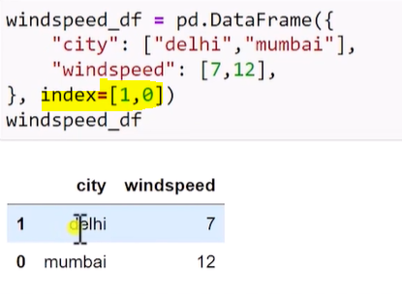

**Axis=1 is column wise(personal understanding – row update)**

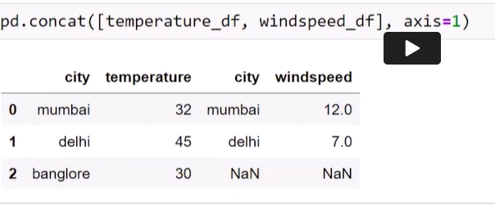

**Merge operation**

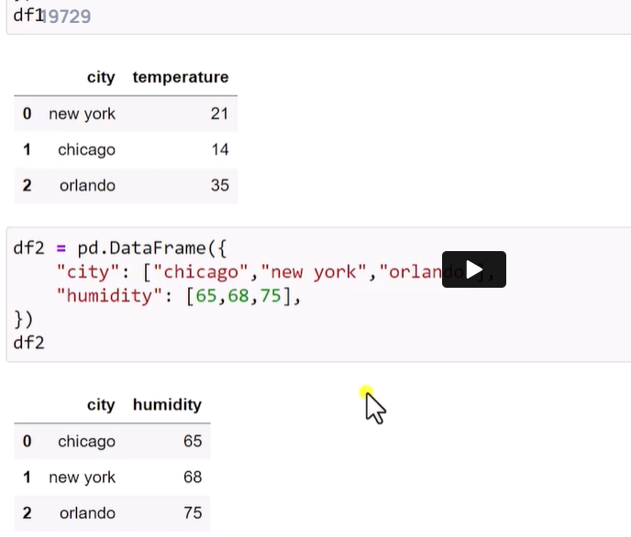

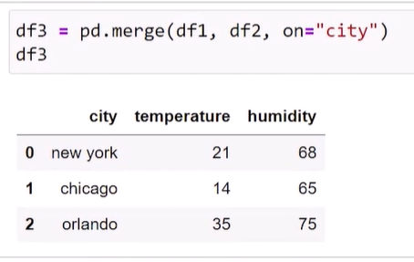

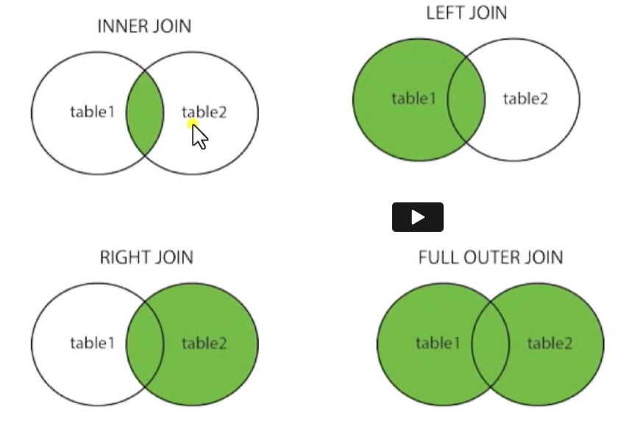

**Left, right and outer conditions**

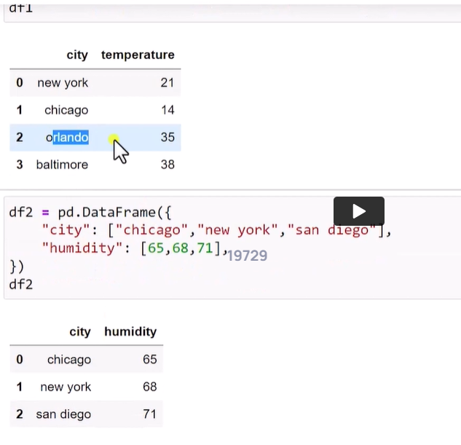

Inner :

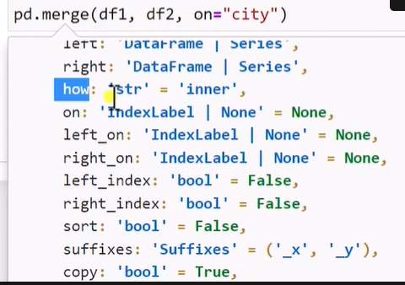

**Data common in both has come**

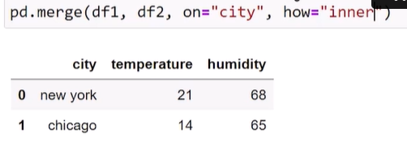

**Df2 only data has not come in this**

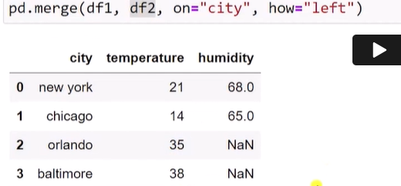

**Outer join**

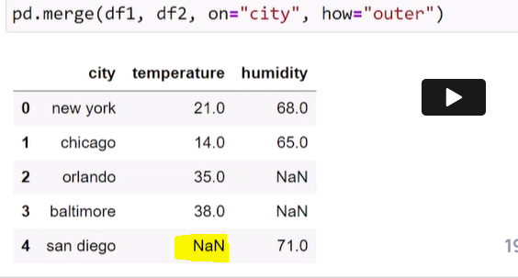

**Matplotlib and Seaborn**

**Installing seaborn within notebook**

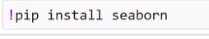

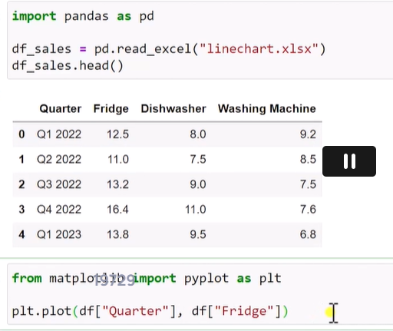

**Plt.figure(figsize=(12,4)) - 12 – x axis and 4 – Y-axis**

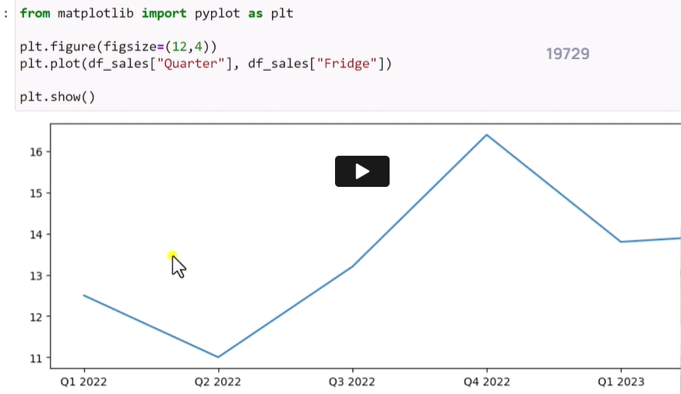

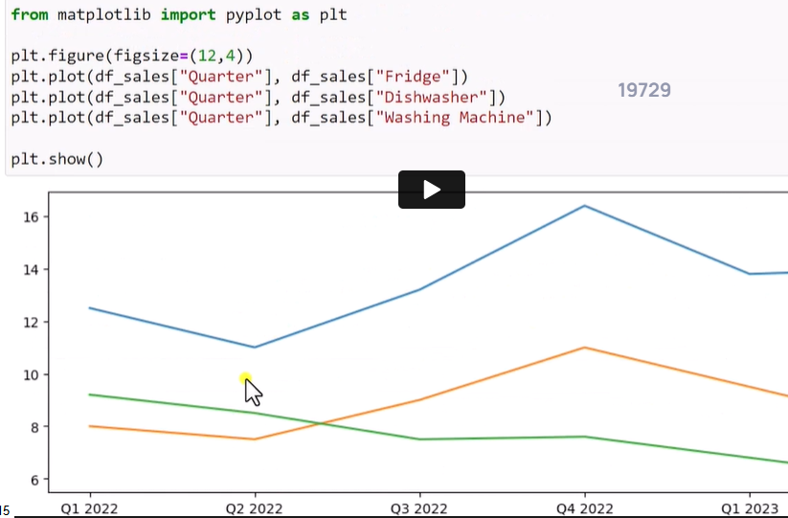



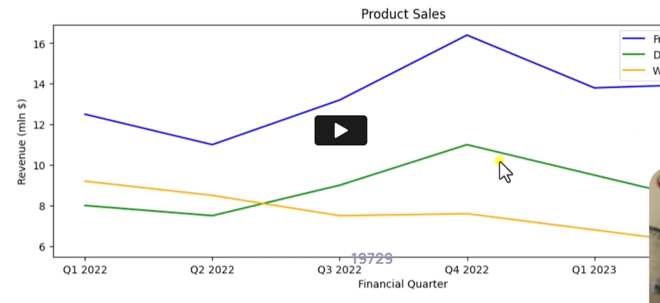



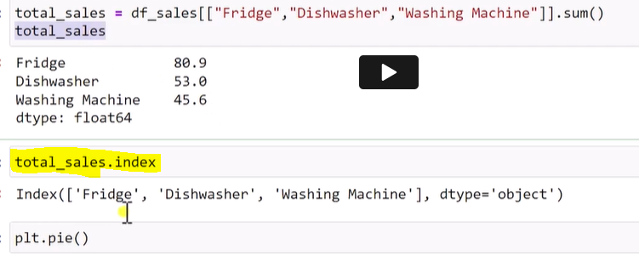

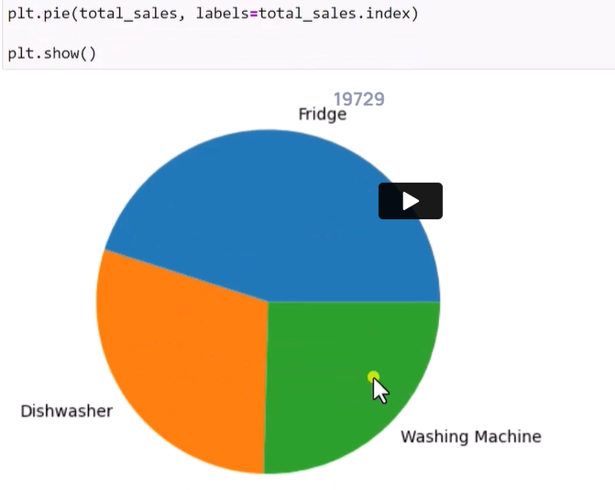

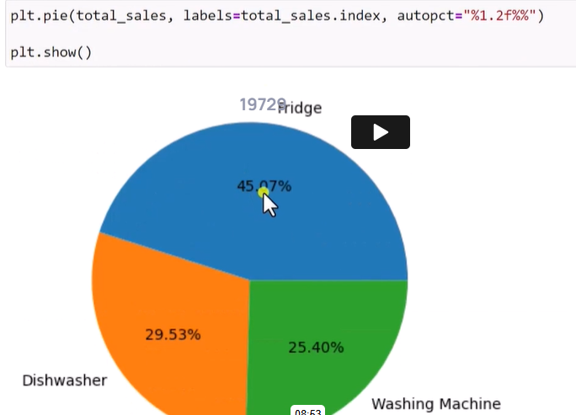

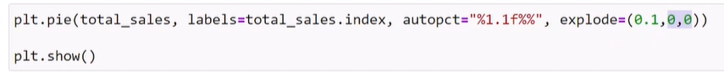

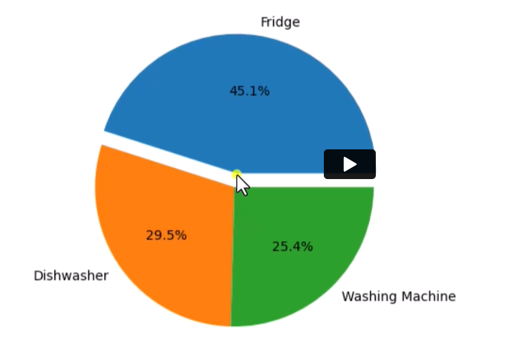

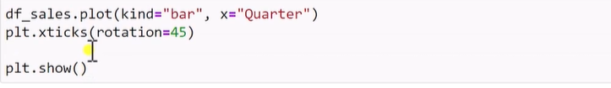

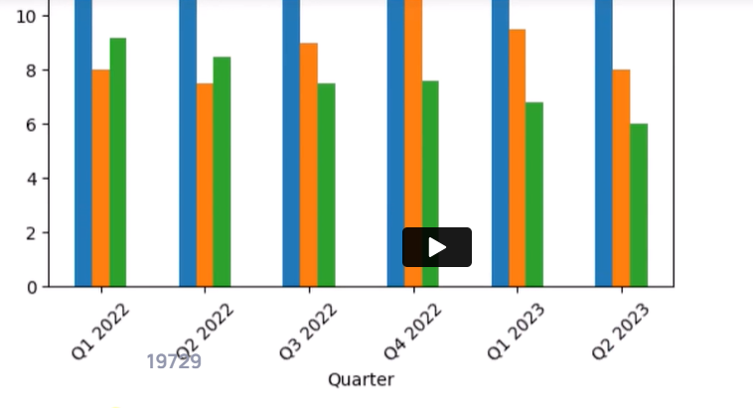

**Change index to Quarter.**

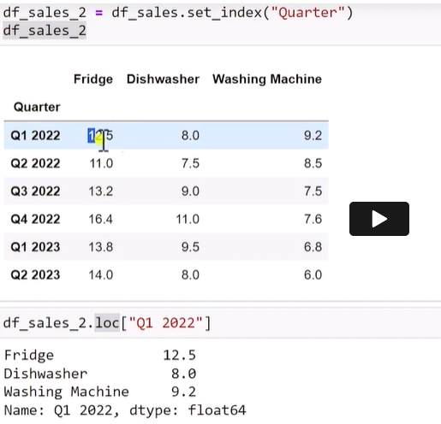

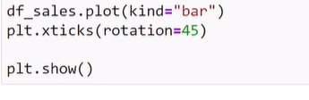

**Seaborn library**



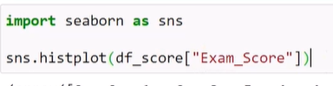

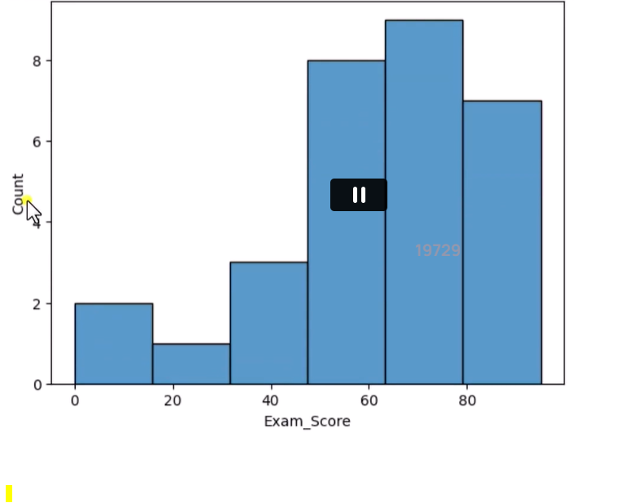

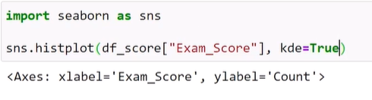

Kde = kernel density estimator

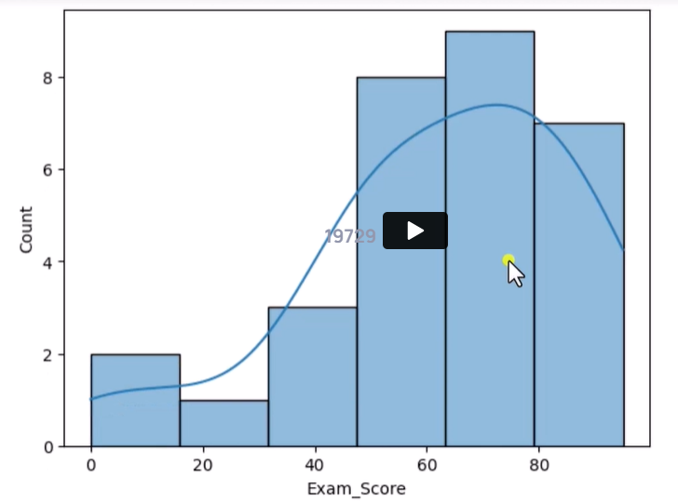

**Other way of doing the same plot**



**Scatter plot**

